Troubleshooting Website Reachability behind a Load Balancer (Assessment Version)

**SAL-TF-200-NWTWRL-1 - Version 1.0.1**

© 2024 Amazon Web Services, Inc. or its affiliates. All rights reserved. This work may not be reproduced or redistributed, in whole or in part, without prior written permission from Amazon Web Services, Inc. Commercial copying, lending, or selling is prohibited. All trademarks are the property of their owners.

Note: Do not include any personal, identifying, or confidential information into the lab environment. Information entered may be visible to others.

Corrections, feedback, or other questions? Contact us at [*AWS Training and Certification*](https://support.aws.amazon.com/#/contacts/aws-training).

**Lab overview**

The lab covers the concepts of configuring a web server behind an Elastic Load Balancer (ELB). The lab presents a scenario where users are not able to reach a website hosted on an Amazon Elastic Compute Cloud (Amazon EC2) instance behind a load balancer.

Your goal is to troubleshoot and fix all the misconfigured issues to allow accessing the website page using the load balancer DNS name while ensuring the solution can still work if one of the web servers instances is down.

High-level guidance and references are provided to assist you in fixing the issue. The detailed solution instructions are provided in a collapsible section which you can expand.

OBJECTIVES

By the end of this lab, you should be able to do the following:

* Examine the current configuration of the Application Load Balancer (ALB) and the website running on EC2 instances behind the ALB.
* Troubleshoot and identify the issues in the existing configuration which are preventing users from accessing the website.
* Remediate the configuration to allow users to access the website behind the ALB and ensure the solution is highly available.

TECHNICAL KNOWLEDGE PREREQUISITES

To successfully complete this lab, you should have a basic knowledge of:

* Navigating through the AWS Management Console.
* Elastic Load Balancer (ELB).
* Amazon Virtual Private Cloud (Amazon VPC).
* Amazon Elastic Compute Cloud (Amazon EC2).

DURATION

This lab requires approximately *60* minutes to complete.

ICON KEY

Various icons are used throughout this lab to call attention to different types of instructions and notes. The following list explains the purpose for each icon:

* **Note:** A hint, tip, or important guidance.
* **Hint:** A hint to a question or challenge.
* **Task complete:** A conclusion or summary point in the lab.
* **Consider:** A moment to pause to consider how you might apply a concept in your own environment or to initiate a conversation about the topic at hand.

**Start lab**

1. To launch the lab, at the top of the page, choose **Start lab**.

**Caution:** You must wait for the provisioned AWS services to be ready before you can continue.

1. To open the lab, choose **Open Console**.

You are automatically signed in to the AWS Management Console in a new web browser tab.

**WARNING:** **Do not change the Region unless instructed.**

COMMON SIGN-IN ERRORS

**Error: You must first sign out**

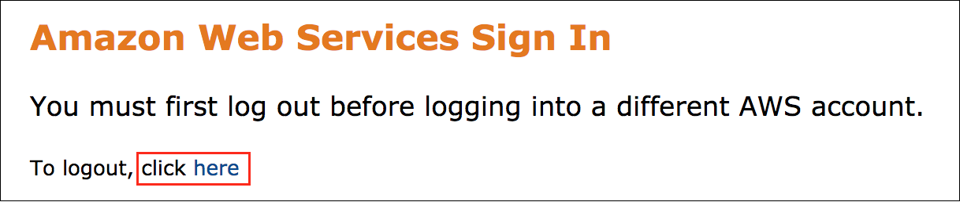

If you see the message, **You must first log out before logging into a different AWS account:**

* Choose the **click here** link.
* Close your **Amazon Web Services Sign In** web browser tab and return to your initial lab page.
* Choose **Open Console** again.

**Error: Choosing Start Lab has no effect**

In some cases, certain pop-up or script blocker web browser extensions might prevent the **Start Lab** button from working as intended. If you experience an issue starting the lab:

* Add the lab domain name to your pop-up or script blocker’s allow list or turn it off.
* Refresh the page and try again.

LAB ENVIRONMENT

The following diagram shows the lab scenario:

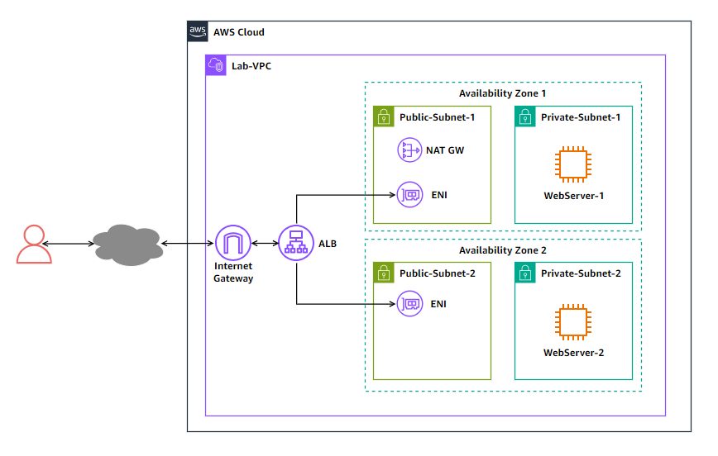

*Image description: The following list details the major resources in the lab:*

* *A VPC hosting all the lab resources.*
* *The VPC has two public subnets and two private subnet across two availability zones.*
* *The VPC has an internet gateway allowing public access from the internet.*
* *A NAT gateway in one of the public subnets to provide outbound access from the private subnets.*
* *An Application Load Balancer (ALB) with an elastic network interface (ENI) in each of the public subnets.*
* *An EC2 instance in each of the private subnets to host the website.*

AWS SERVICES NOT USED IN THIS LAB

AWS service capabilities used in this lab are limited to what the lab requires. Expect errors when accessing other services or performing actions beyond those provided in this lab guide.

**Task 1: Testing the web server reachability from the internet**

In this task, you test the web server reachability from the internet to verify the issue. Since the web server is in a private subnet behind the load balancer, you attempt reaching the web server using the load balancer DNS name.

1. Copy the **ALBDNSName** value that is listed to the left of these instructions. Paste the value into a new browser tab, and then press **Enter**.

After couple of minutes, your browser page fails to connect to the web server and returns a message to indicate that the page cannot be reached. This verifies that the website is not reachable.

1. Close the browser tab that you attempted to access the **ALBDNSName** with.

**Task complete:** You tested the website reachability from the internet and verified that it cannot be reached.

**Task 2: Troubleshooting and remediating website reachability issues**

In this task, you identify the issues in the existing configuration and remediate the configuration so the website can be accessed from the internet using the load balancer DNS name.

Now that have you confirmed the issue, you need to identify the services and resources which were misconfigured and remediate them.

You can navigate through the AWS Management Console of the EC2, VPC, or any other service you need to identify the issues in the current configuration and determine how to remediate them.

**Consider:** Here are few things to consider when you attempt remediating the issue:

* The HTTP service is up and running on both web server instances so you do not need to troubleshoot it.
* The website HTML files and settings are correctly configured on both web server instances so you do not need to troubleshoot it.
* The HTTP service on the web servers are running on the standard HTTP port (TCP port 80).
* You do not need to create new resources to resolve the issue. However, you can modify existing resources.

RESOLVE THE WEBSITE REACHABILITY - DO IT YOURSELF

**Hint:** Here are some references to assist you in solving the issue:

* [Why can’t clients connect to my Elastic Load Balancing load balancer?](https://repost.aws/knowledge-center/elb-connectivity-troubleshooting)
* [Troubleshoot your Application Load Balancers](https://docs.aws.amazon.com/elasticloadbalancing/latest/application/load-balancer-troubleshooting.html)

SOLUTION

Expand the *Detailed instructions* section below for the full solution.

**Detailed instructions**

VERIFYING THE WEBSITE REACHABILITY

To verify that you resolved all the issues, you can simply attempt to access the website from your browser using the load balancer DNS name.

1. Copy the **ALBDNSName** value that is listed to the left of these instructions. Paste the value into a new browser tab, and then press **Enter**.

The browser should return the website page which should include the web server instance name *WebServer-1* where the website is hosted. The page also displays the EC2 instance ID for *WebServer-1*. You can verify this instance ID with the value of *WebServer1InstanceID* which is listed to the left of these instructions.

**Note:** It may take 1-2 minutes for the instance to become healthy before you can reach it via the load balancer DNS name.

1. Close the browser tab of **WebServer-1**.

**Task complete:** You identified the issues in the existing configuration and remediated the configuration so the website can be accessed from the internet using the load balancer DNS name.

**Task 3: Ensuring the solution is highly available**

After remediating the website reachability issues, you need to improve the solution resiliency to mitigate against any potential failure in the instance hosting the website.

In this task, you make configure your solution to be highly available to ensure that the website is still reachable even if one instance is down.

First, you stop the instance currently hosting the website and check if the website is still reachable or not.

1. In the navigation pane at the left of the page, under **Instances** section, choose **Instances**.
2. In the list of instances, select the **WebServer-1** instance.
3. From the **Instance state** menu at the top of the page, select **Stop instance**.
4. In the **Stop instance?** popup window, choose **Stop**.

A message banner indicates that the instance was stopped successfully.

Now, check if you can still access the website.

1. Copy the **ALBDNSName** value that is listed to the left of these instructions. Paste the value into a new browser tab, and then press **Enter**.

Your browser page fails to connect to the web server.

Even though you have a second instance *WebServer-2* hosting the website, the website is not reachable when the first instance is down.

1. Close the browser tab that you attempted to access the **ALBDNSName** with.

RESOLVE THE SINGLE-POINT OF FAILURE ISSUE - DO IT YOURSELF

Try to troubleshoot and remediate the issue so that website is still reachable even when the *WebServer-1* instance is down.

If you are stuck, expand the *Detailed instructions* section below for the full solution.

**Detailed instructions**

VERIFYING THE SOLUTION

To verify that your solution, attempt to access the website using the load balancer DNS name while the *WebServer-1* instance is still down (stopped).

1. Copy the **ALBDNSName** value that is listed to the left of these instructions. Paste the value into a new browser tab, and then press **Enter**.

The browser should return the website page which should include the web server instance name *WebServer-2* where the website is hosted. The page also displays the EC2 instance ID for *WebServer-2*. You can verify this instance ID with the value of *WebServer2InstanceID* which is listed to the left of these instructions.

Now, start the *WebServer-1* instance to verify that load balancing is working between the two instances.

1. In the navigation pane at the left of the page, under **Instances** section, choose **Instances**.
2. In the list of instances, select the **WebServer-1** instance.
3. From the **Instance state** menu at the top of the page, select **Start instance**.

A message banner indicates that the instance was started successfully.

Now, check the instance status in the target group.

1. In the navigation pane at the left of the page, under **Load Balancing** section, choose **Target Groups**.
2. In the **Load balancers** section, choose the **Lab-lb** link.
3. In the list of target groups, select the **Lab-WebServer-TargetGroup** target group
4. Choose the **Targets** tab to check the instances in the group.

Note that the bot instances health status are now healthy.

**Note:** You may need to choose the refresh icon  to refresh the health status of the target.

Return to the browser tab where you access the load balancer DNS name and refresh the browser multiple times. You note that the page alternates between the two instances as the indicated by the web server name and instance id displayed on each page.

**Consider:** Here is a quick recap of what you learned from troubleshooting the scenario:

* The load balancer listener must be configured with the correct protocol and port.
* The security groups on both the load balancer and instances must be configured to allow the desired traffic.
* The load balancer target group must have targets added and their health status as healthy for the load balancer to send traffic to the target.

**Task complete:** You configured your solution to be highly available to ensure that the website is still reachable even if one instance is down.

**Conclusion**

You have successfully done the following:

* Examined the current configuration of the Application Load Balancer and website running on EC2 instances behind the ALB.
* Troubleshooted and identified the issues in the existing configuration which are preventing users from accessing the website.
* Remediated the configuration to allow users to access the website behind the ALB and ensured the solution is highly available.

**End lab**

Follow these steps to close the console and end your lab.

1. Return to the **AWS Management Console**.
2. At the upper-right corner of the page, choose **AWSLabsUser**, and then choose **Sign out**.
3. Choose **End lab** and then confirm that you want to end your lab.

**Additional resources**

* [What is Elastic Load Balancing?](https://docs.aws.amazon.com/elasticloadbalancing/latest/userguide/what-is-load-balancing.html)

For more information about AWS Training and Certification, see [*https://aws.amazon.com/training/*](https://aws.amazon.com/training/).

*Your feedback is welcome and appreciated.*  
If you would like to share any feedback, suggestions, or corrections, please provide the details in our [*AWS Training and Certification Contact Form*](https://support.aws.amazon.com/#/contacts/aws-training).